|  |  |  |
| --- | --- | --- |
| FESTIVAL |  |  |
| DATE  STARTING 10-01-2023  SUBMITING 09-02-2023 | SUPERVISER  Ms.Ambreen Mehmood | batch  2209C1 |
|  |  |  |

| SERIAL NO. | enrollment | STUDENT nAME |
| --- | --- | --- |

|  |  |  |
| --- | --- | --- |
| 1. | Student1418832 | TAQI KAZMI |
| 2. | Student1419321 | SHAZAIB Amir |
| 3. | Student1419347 | SIDDIQA ASGHAR |
| 4. | Student1419139 | HASSAN KAZMI |

***NAVBAR***

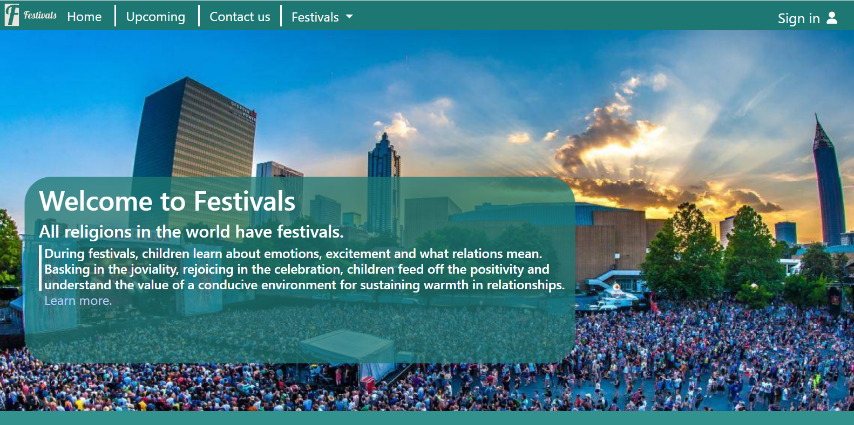

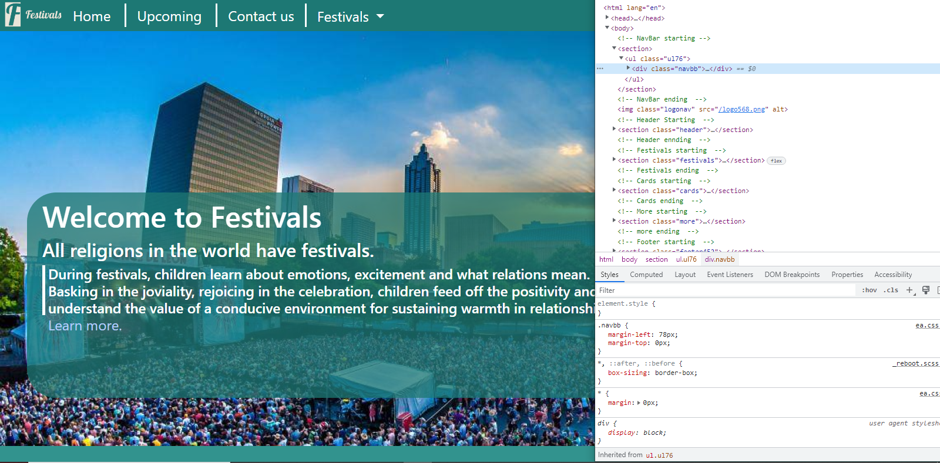

***CONTACT US***

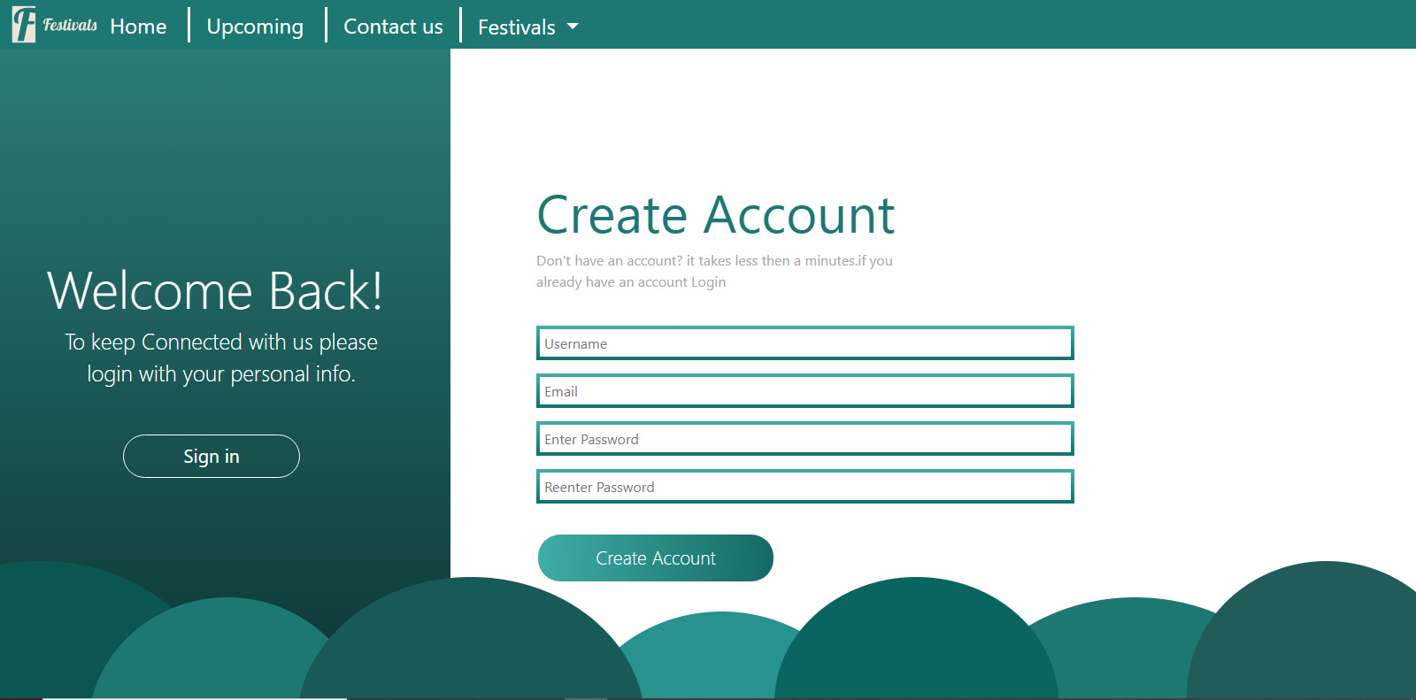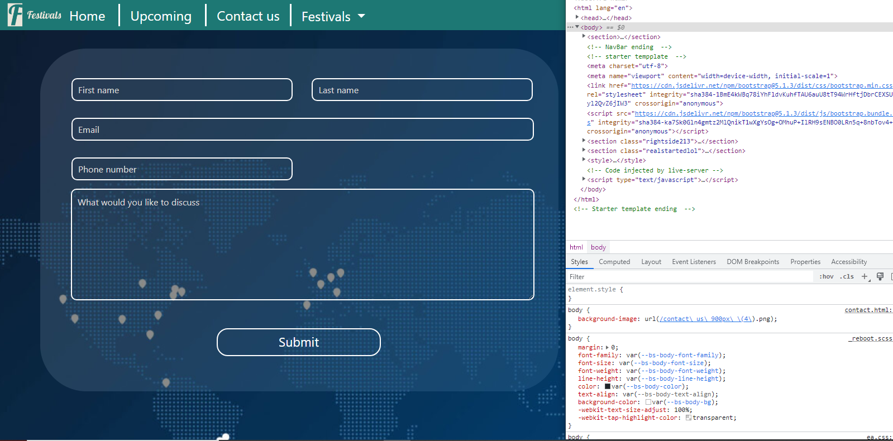

***FOOTER***

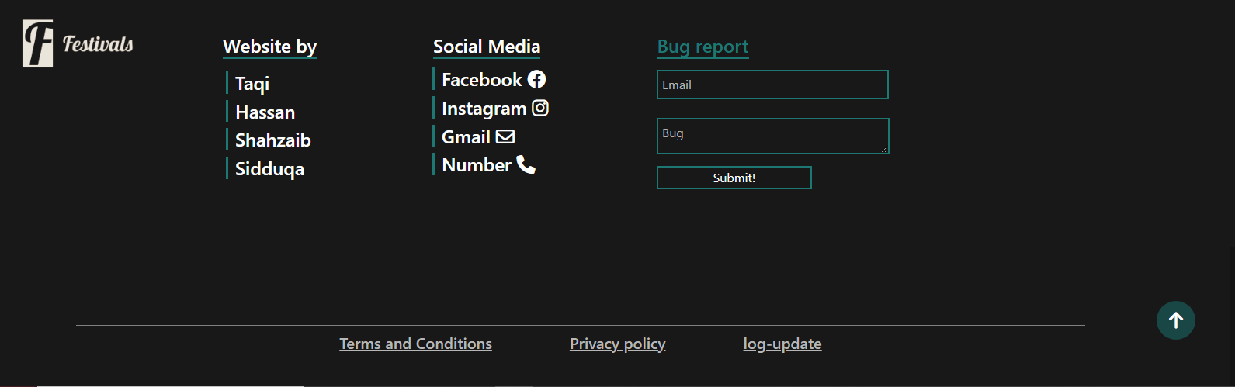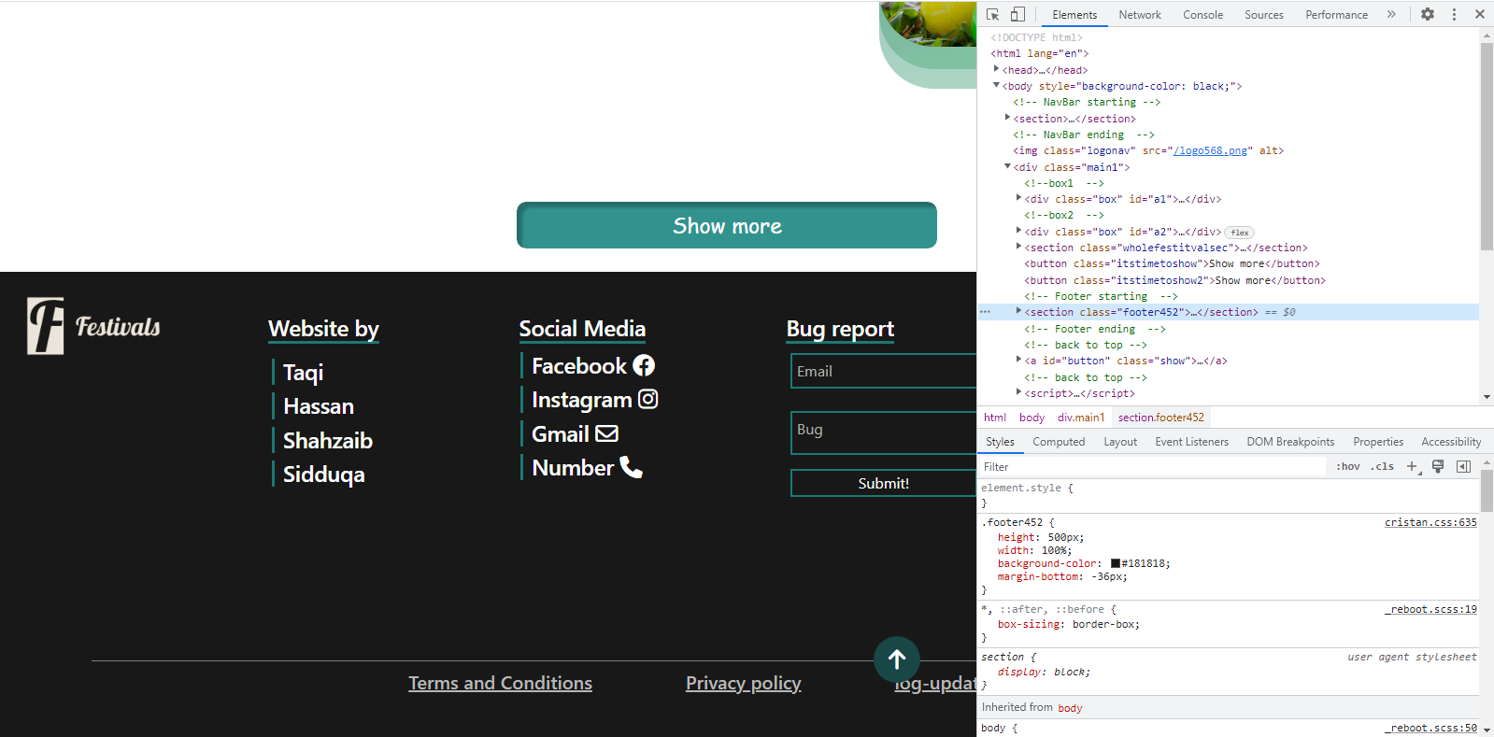

***SLIDER***

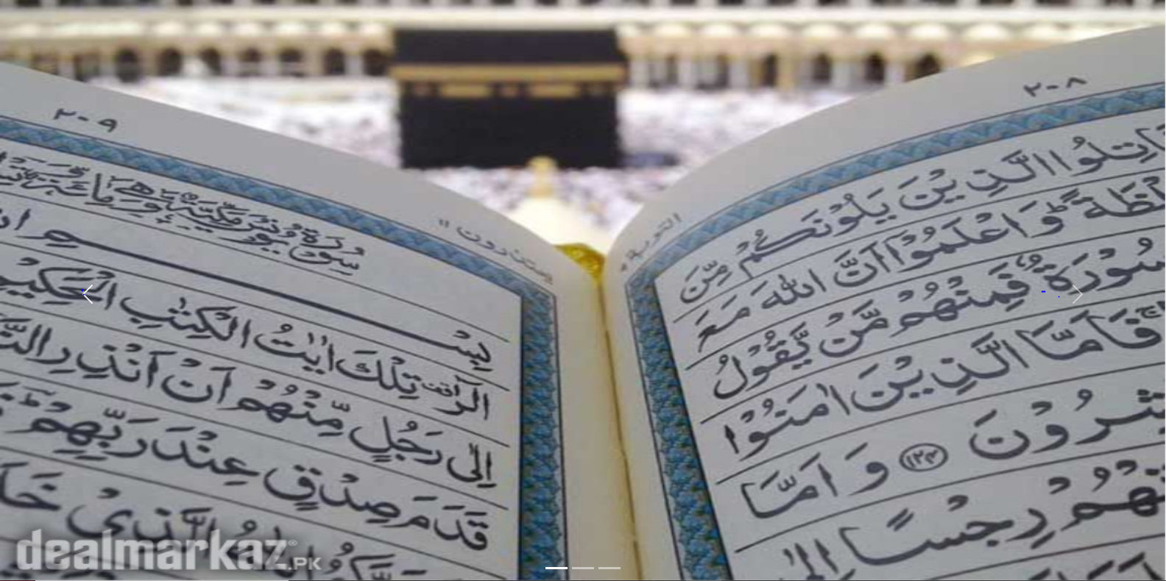

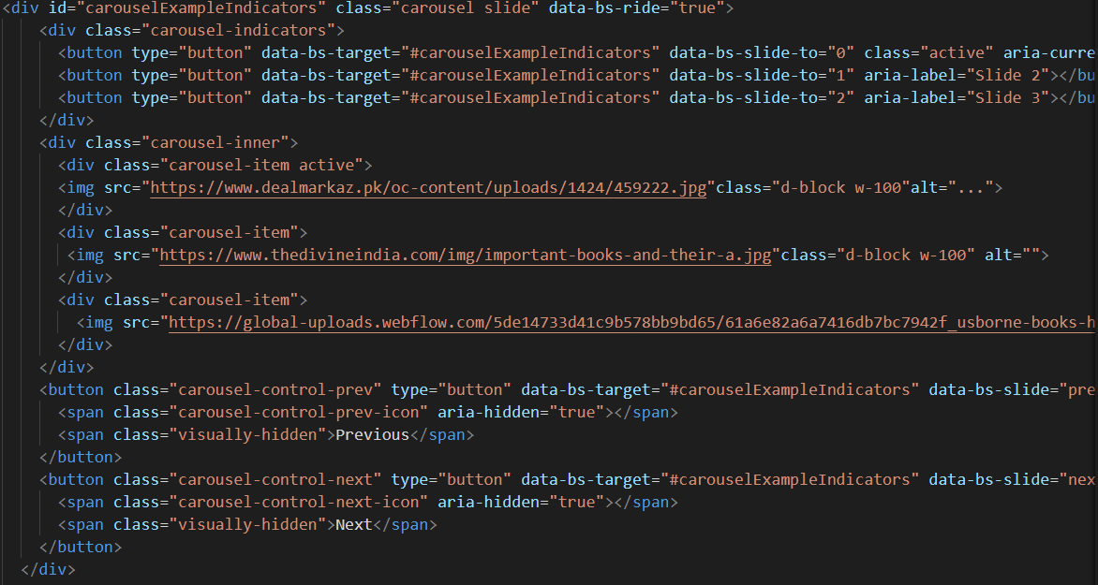

***Thank You For Reading The Documentation.***

***Please Follow The Instructions Above !!***